MULTI LINE INSURANCE POLICY
AND CLAIMS MANAGEMENT
SYSTEM

Milestone 2: Complex Policy Issuance & Claim Routing ( Proof)

TEAM 7 MEMBERS :

NAME : R.HARIHARAN
ROLL NO : 822223104033
NM ID: 89EB08A5DEDC3B48B3349612B3B64218
EMAIL ID : hhariharan708@gmail.com

NAME : T.MUTHAMILSELVAN
ROLL NO : 822223104038
NM ID: 6C4BDAACAD9BB1FB31A47784B2502B96
EMAIL ID : t.muthamil555@gmail.com

Name :C.T.BHUVANESH
ROLL NO :822223104042
NM ID : DB1E37315FFD9B494E546AB8931A54DA
EMAIL ID : bhuvameshthi@gmail.com

Milestone 2: Complex Policy Issuance & Claim Routing Automation
- Create an Apex Class (PremiumCalculator) with a method that accepts policy data
- Click on setup icon, Right click on developer console, Open
the link in new tab
- At the top left corner, click on the file, then click on new, and click on Apex class, Give the name as PremiumCalculator and click on create.
- Paste the following code in the apex class:

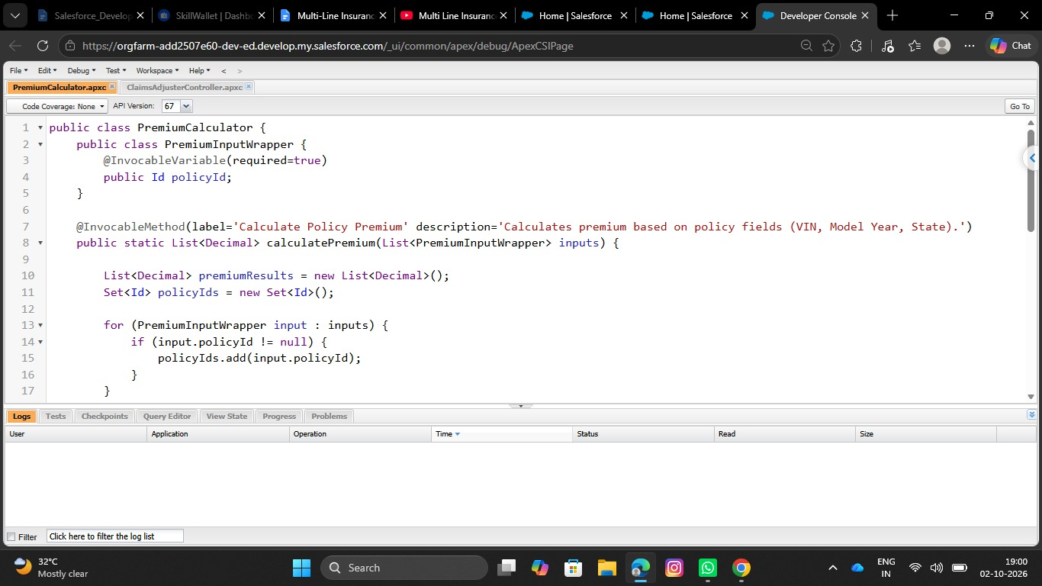

- Click on CTRL + S to save the apex class
- And this apex class need to be invoked in the AutoQuotingFlow

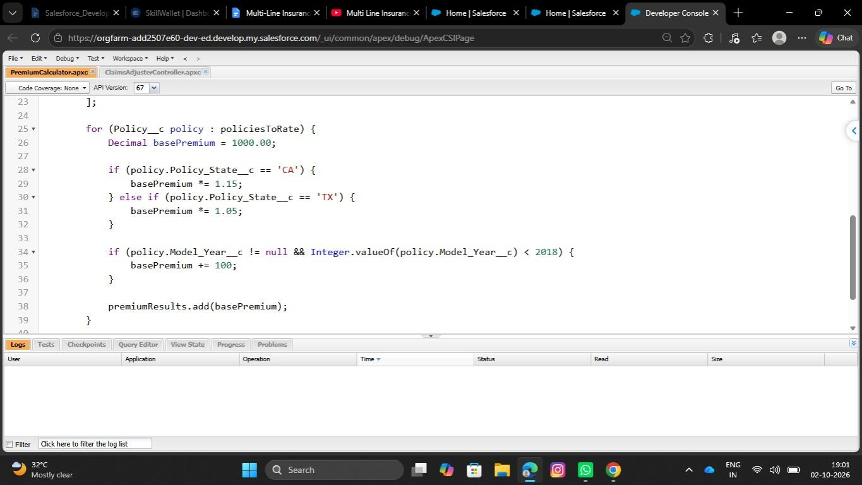
- Integrate this Apex action into the final step of the AutoQuotingFlow to update the draft Policy record

- Go to setup, in the quick find box search for flows and click on flows
- Find for AutoQuotingFlow and open in the flow builder
- Under the Create Records element,
- Add an action element after the create records element.
- Give the label as Calculate Premium Action
- API Name will be auto populated
- Under set Input values, For policy Id, Set the varPolicyId variable created in the previous step
- Under view output resources, check the manually assign variables checkbox and for the output placeholder, create a resource
- Resource type would be variable, API Name would be varCalculatedPremium, Data type would be currency, Decimal places are ‘2’ and click Done.

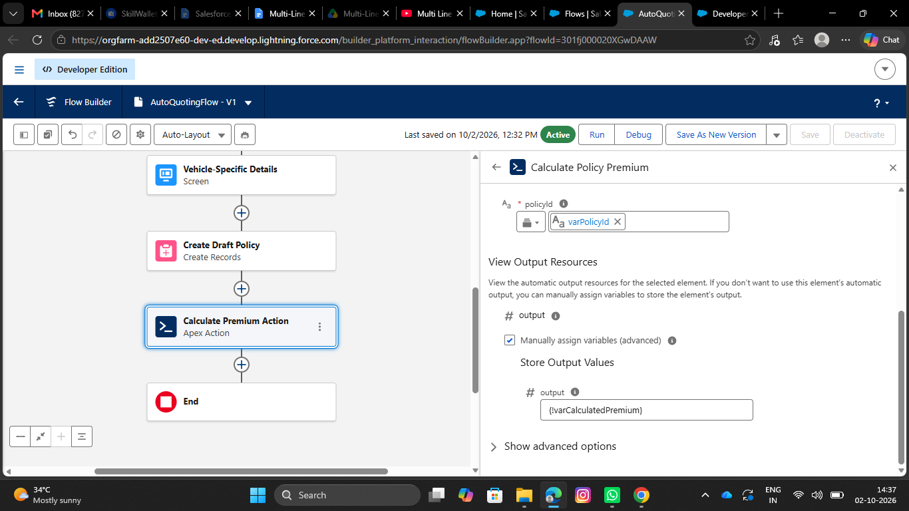
- After the action element, add the update records element, Give the label as Update Policy With Premium
- For how to find records to update and set their values, Select Specify conditions to identify records, and set fields individually
- Select object as policy
- Select all conditions are met for filter criteria
- The conditions include:
- Record Id Equals varPolicyId variable
- Under set field values for policy record
- Assign varCalculatedPremium variable to the Premium field
- 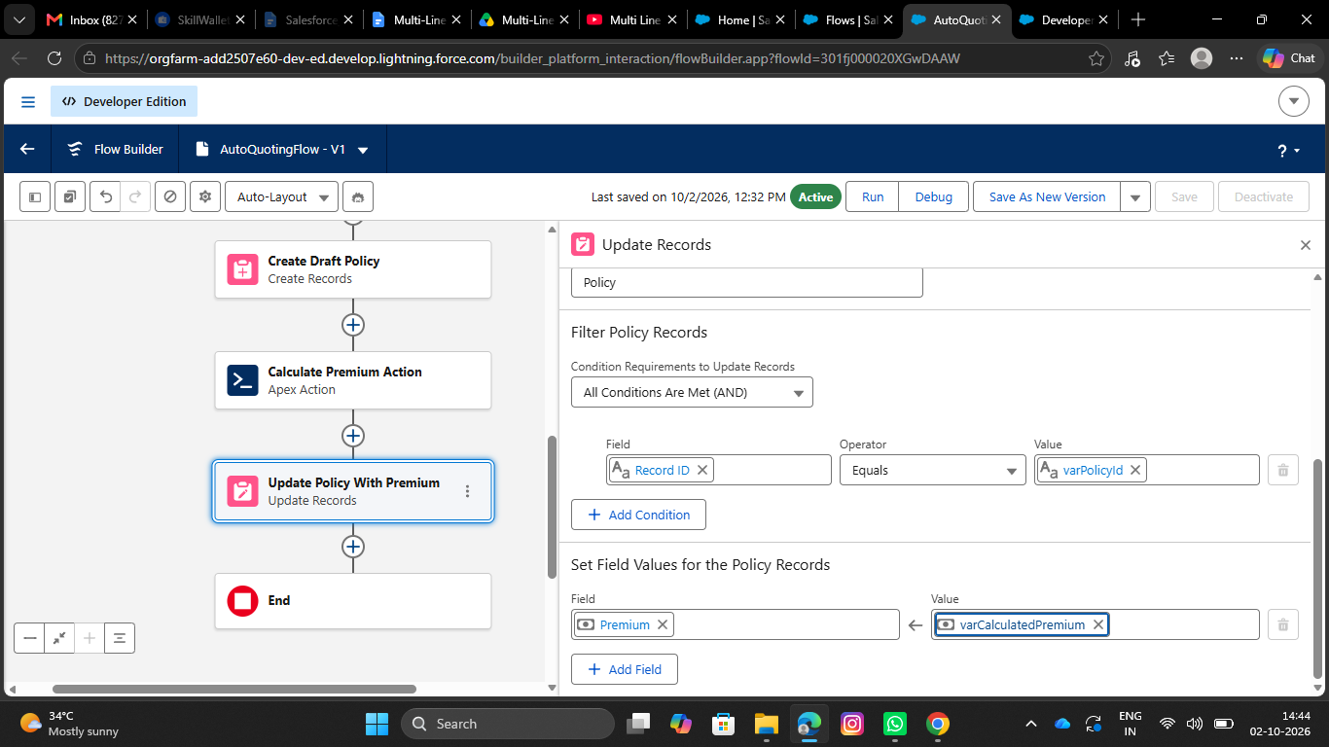
- Activate the flow.
- Save the flow as a new version
Create a Record-Triggered Flow (After Save) on the Claim object
- Go to setup, In the quick find box, Search for flows and click on flows
- Click on New Flow, select Record Triggered Flow and Click on Create
- Select Claim for an object
- Configure trigger when the record is created
- Optimize flow for action and Related Records

- 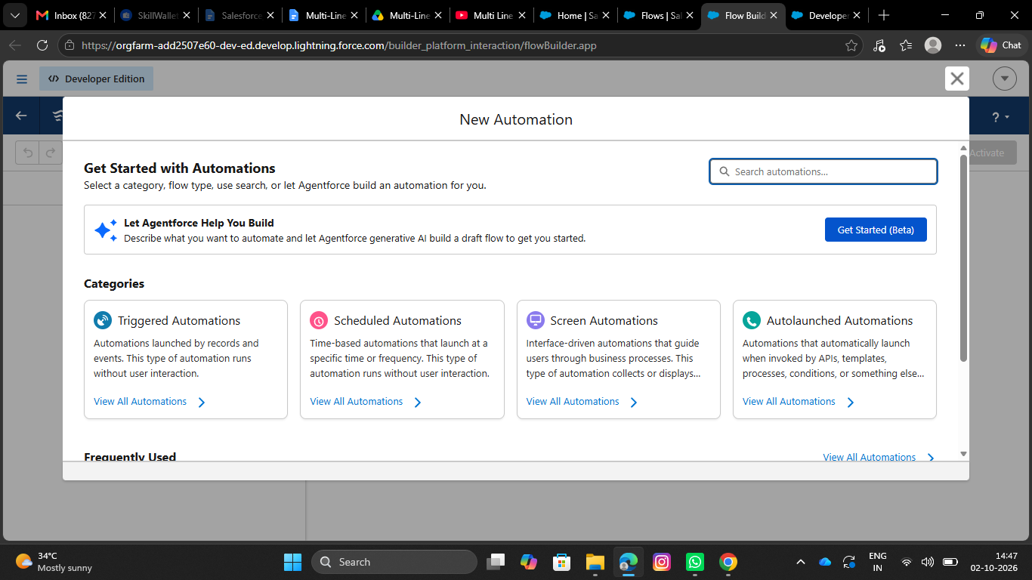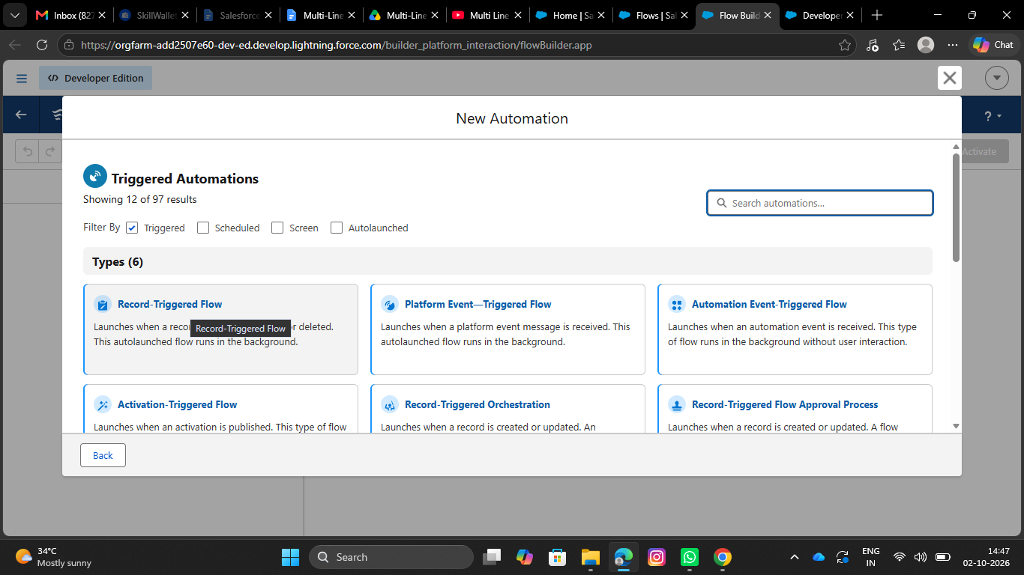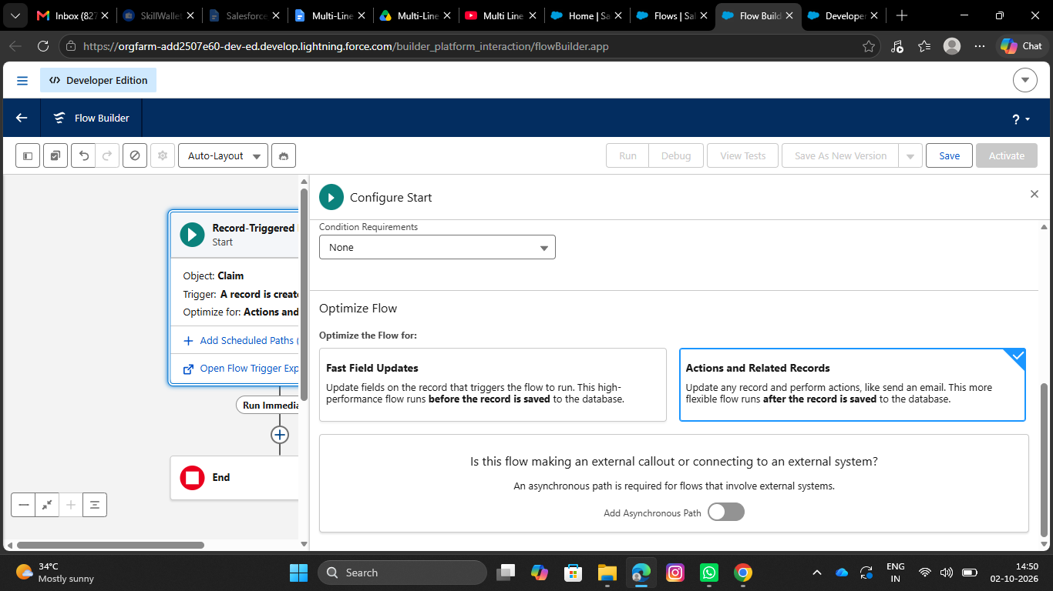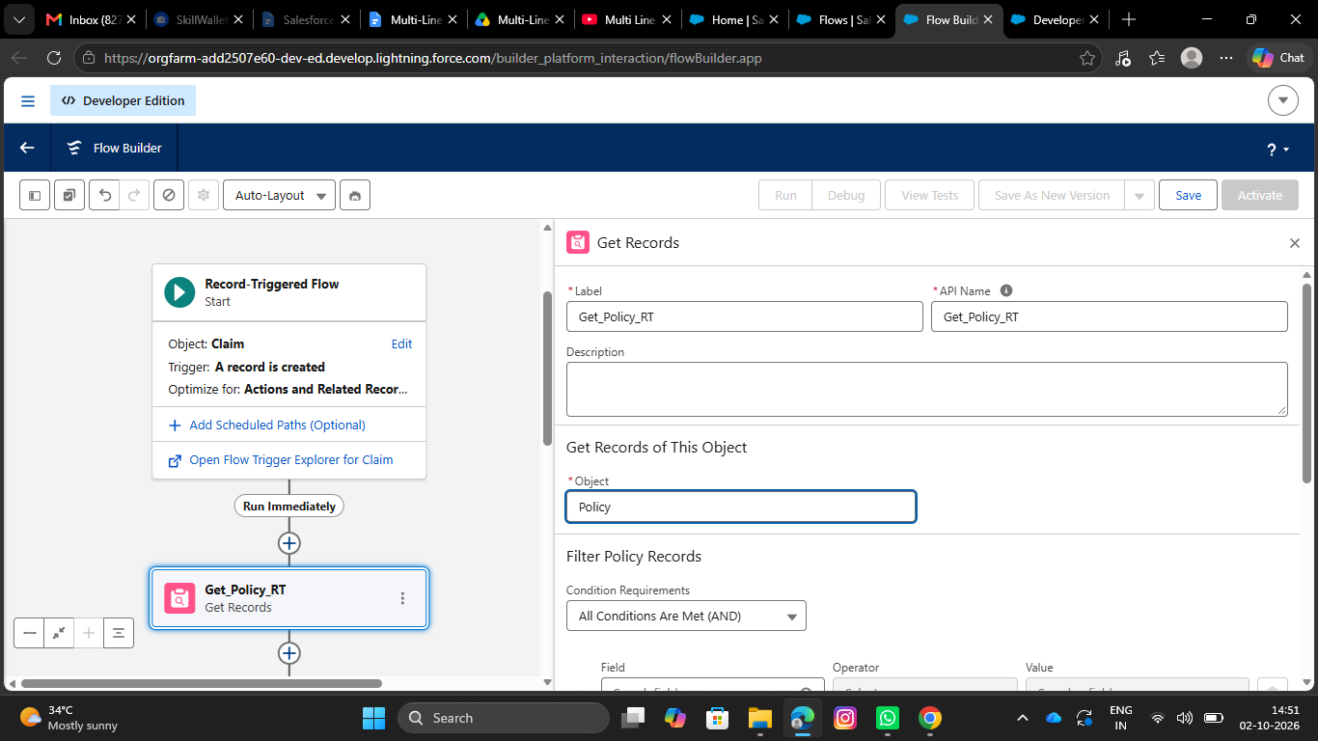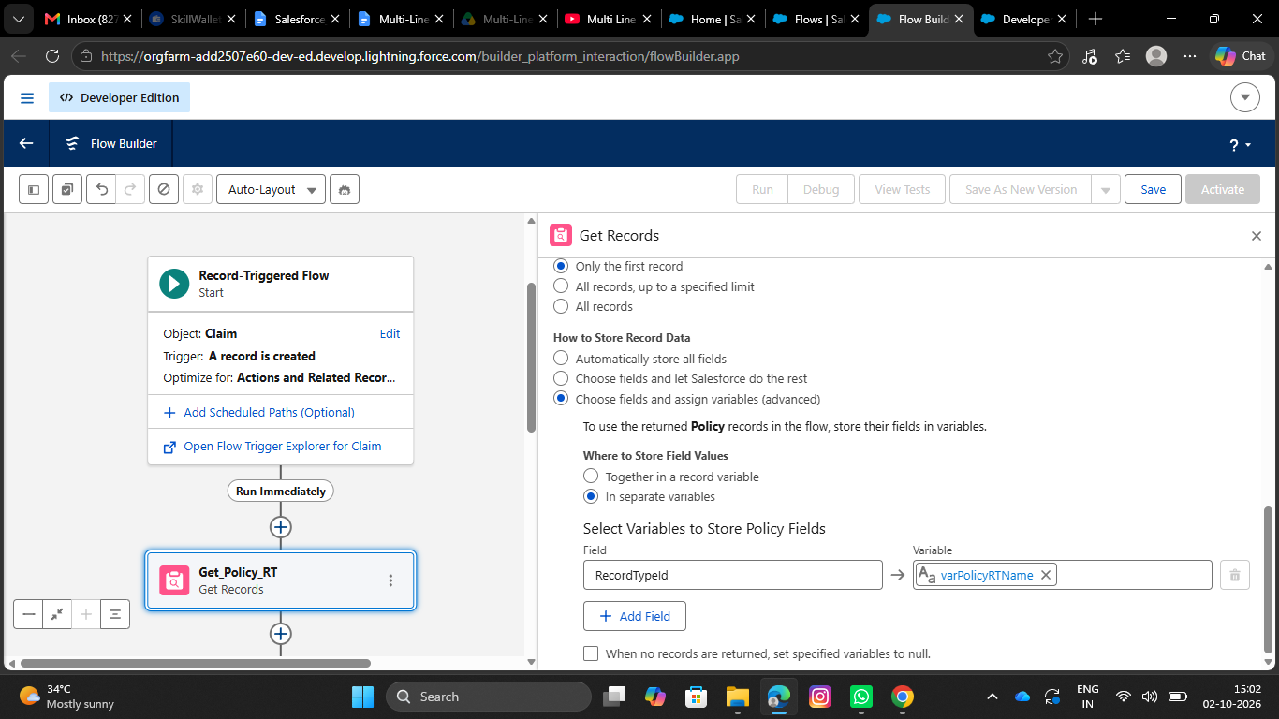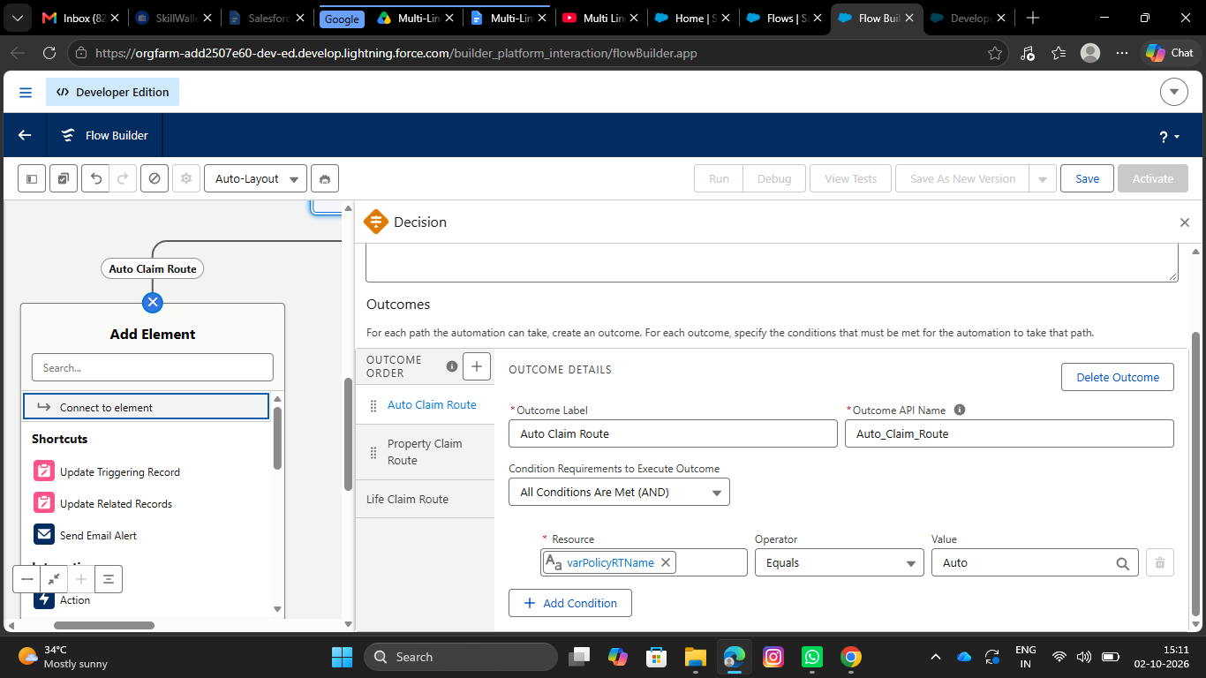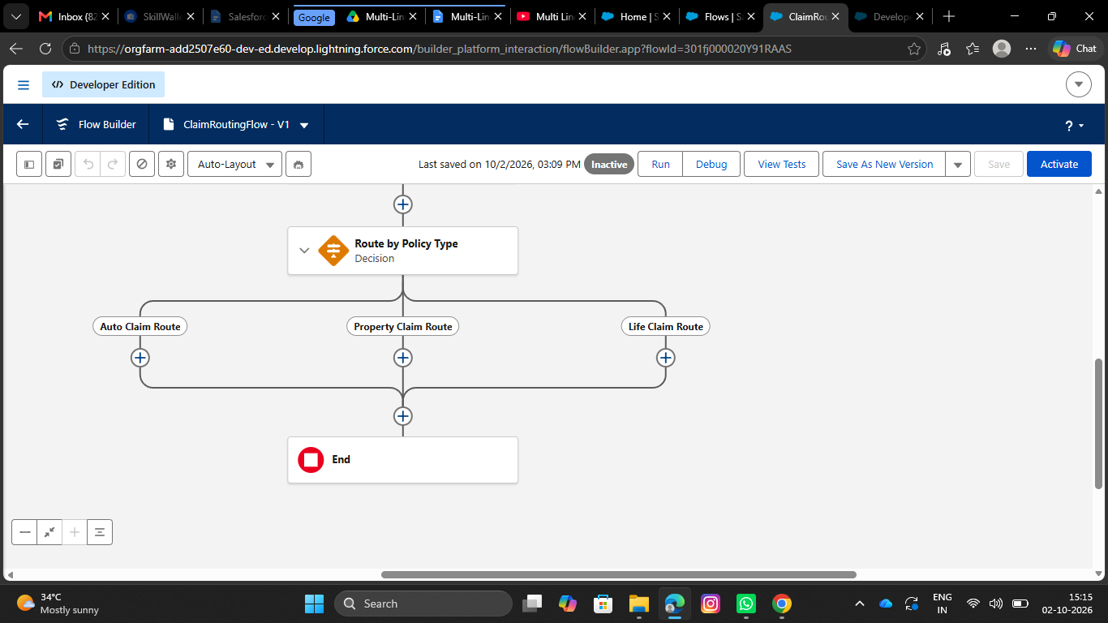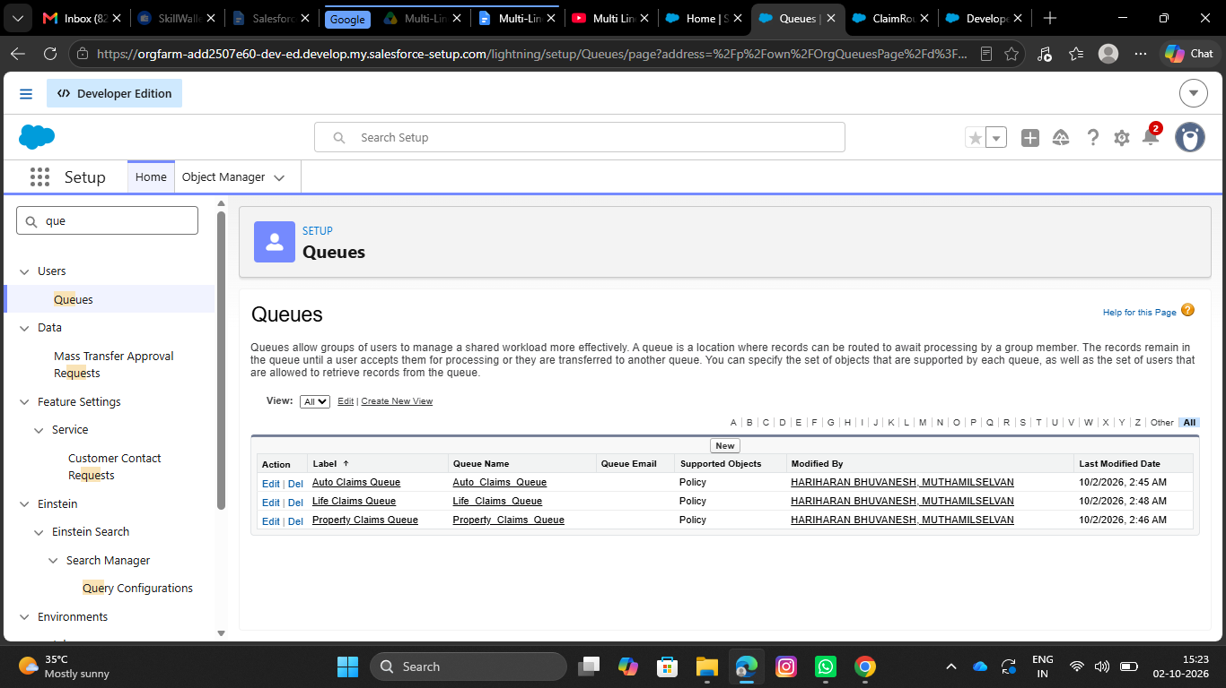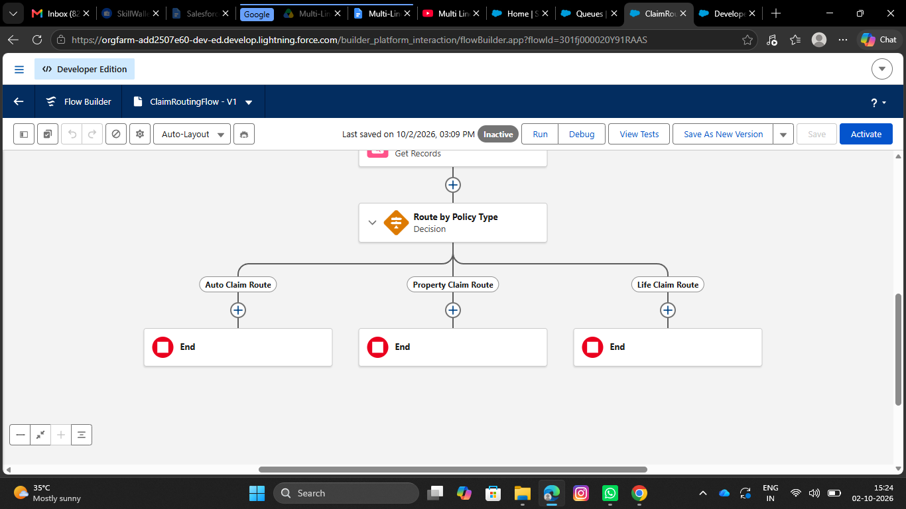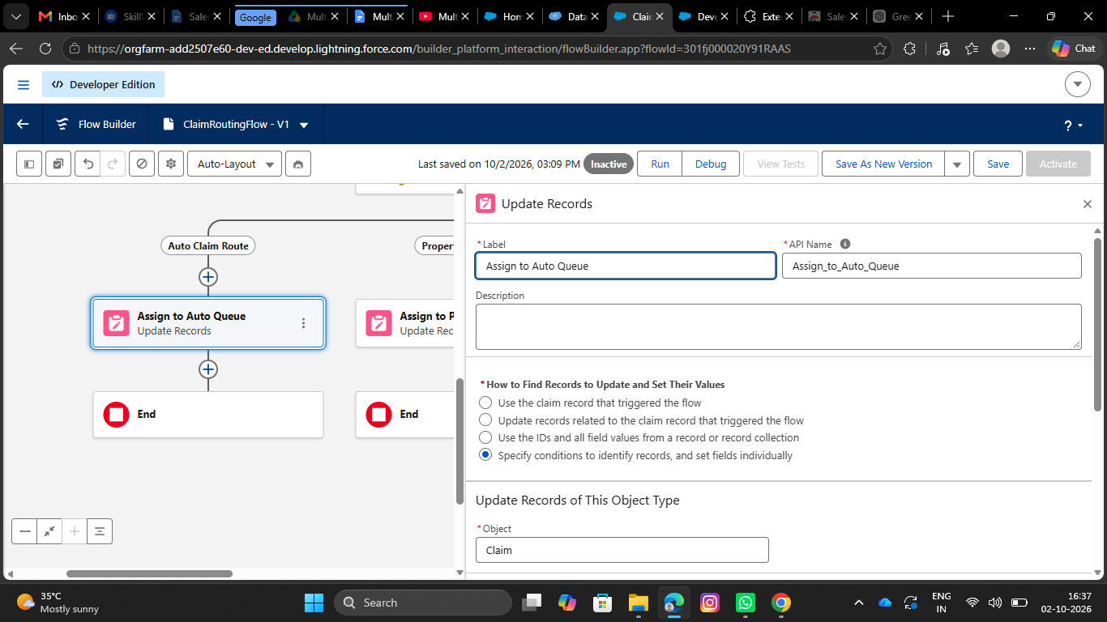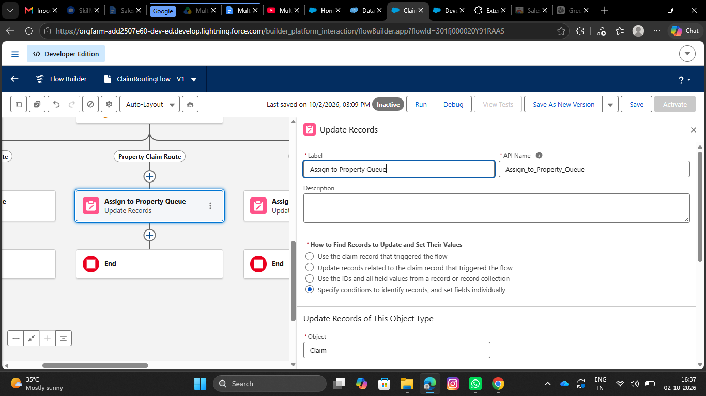
- Under Property Claim Route Decision path, add the update records element
- Label it as Assign to Property Queue
- API name will be auto populated
- Under How to find records to update and set their fields, select specify conditions to identify records
- Select Claim as an object
- Select All conditions are true for Conditional requirements
- The conditions include:
- Record Id equals Triggering Claim → Record ID
- Under Set fields for the Claim Records
- Set the hardcoded Property queue 18 digit Id for Owner ID field
- Under Life Claim Route Decision path, add the update records element
- Label it as Assign to Life Queue
- API name will be auto populated
- Under How to find records to update and set their fields, select specify conditions to identify records
- Select Claim as an object
- Select All conditions are true for Conditional requirements
- The conditions include:
- Record Id equals Triggering Claim → Record ID

